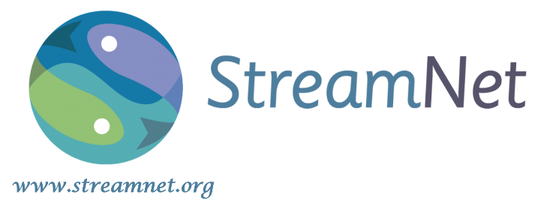
StreamNet Program

The StreamNet Program is a regional forum for fish and aquatic information management and data sharing. StreamNet began in the 1980s to provide standardized information to inform Columbia River basin assessments, reports, and decision-making processes. Starting in 2010, StreamNet further supported regional assessments and decisions in the Pacific Northwest that rely on fish population indicators by becoming a co-sponsor of the Coordinated Assessments Effort (CA Effort). StreamNet also serves as Bonneville Power Administration’s (BPA) system of record for fish distribution and facilities, providing a comprehensive location for partners’ information.

During 2019, StreamNet focused on the work prioritized by the StreamNet Executive Committee, including StreamNet data systems that maintain archived data sets related to fish and other aquatic resources (Data Store), local scale “fish trends” data, GIS maps and data sets, and the CA Effort’s CA Exchange (CAX) for high level indicators (HLIs), resulting with:

- 425,710 application programming interface (API) hits/usage events; the API facilitates efficient sharing and accessing of information on the CAX and StreamNet data systems.
- 18,106 fish trends, consisting of 186,138 records in StreamNet’s local scale “fish trends” data system; this is a cumulative total of all past years combined (Table 1).
- 12,541 new records for CA Effort’s HLIs submitted to CAX (Table 2).
- 9,401 unique visits to the StreamNet website by the public, tribes, and federal and state agencies, and others (excludes repeat visits)
- 6,968 users retrieving information from CAX and local scale data systems.
- 5,794 unique daily users accessing our web-based GIS mapping applications.
- 745 download events of GIS data sets by academic institutions, non-profit organizations, private organizations, tribes, and federal, regional, state, and county/municipal agencies

Additionally, StreamNet PSMFC staff co-hosted the 2019 Smolt Estimation and Analytics Workshop with the Pacific Northwest Aquatic Monitoring Partnership (PNAMP), and co-authored a 2019 white paper on citing aquatic monitoring data sets with PNAMP and the National Oceanic and Atmospheric Administration (NOAA) Fisheries Service West Coast Region. Implementation of the BPA secure data repository initiative, including submission of data sets with no other available secure repository to the StreamNet Data Store, continued to be a priority for StreamNet staff and partners. All StreamNet PSMFC staff and partner data stewards assist data providers and consumers.

The need for effective and timely access to information to inform regional decision-making remains prominent in the Columbia River basin and the Pacific Northwest as a whole. Specifically, BPA, NOAA, and the Northwest Power and Conservation Council (NPCC) have all identified an ongoing need for regionally coordinated, securely stored, and readily accessible data to support their reporting and decision-making processes. Through StreamNet and the CA Effort, PSMFC supports the information needs of NOAA’s 5-year salmon and steelhead status review, BPA’s Federal Columbia River Power System Biological Opinion reporting, and NPCC’s Program Tracker.

StreamNet’s commitment to working cooperatively with tribes, tribal consortia, and federal and state agencies that compile and share Columbia River basin data is critical to its success. StreamNet also partners on collaborative initiatives contributing to improved data management. The information housed at StreamNet includes archived data sets on the Data Store, NPCC Wildlife HEP documents, and fish trends data for resident and anadromous fish species on the StreamNet local scale data system that can be obtained from https://www.streamnet.org/data/. Access to the fish distribution and facilities’ GIS layers that serve as BPA’s system of record are available at https://www.streamnet.org/data/interactive-maps-and-gis-data/. StreamNet also maintains the NPCC Protected Areas, Subbasin Planning, and Hatchery Scientific Review Group data sets: https://www.streamnet.org/services/technical-assistance-to-agencies-and-tribes/npcc-fish-wildlife-program/.

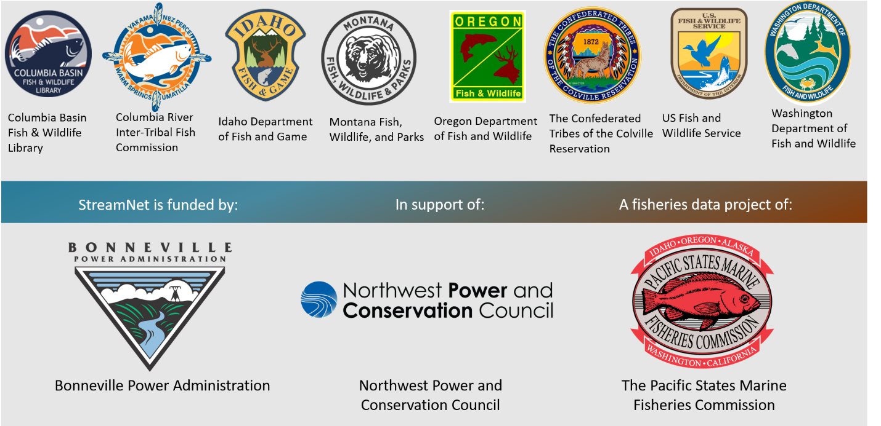
Entities currently represented in StreamNet’s Steering and Executive Committees

The CA Effort provides access to Pacific Northwest fish information that is standardized at the population-level by collaboratively and efficiently sharing HLIs to support reporting and decision-making by natural resource managers and regulators (Table 2). Participants of the CA Effort include fish biologists and data stewards from federal agencies, tribes, states, and tribal consortia who together ensure the data quality and flow. StreamNet PSMFC staff, with assistance from the PNAMP co-sponsor, also leads committees and teams that advance implementation of the CA Effort. More information on the current CA Effort, including the present 5-year plan and historical records, are accessible at https://www.streamnet.org/data/coordinated-assessments/. To view and download data from CAX, which is hosted by StreamNet, visit https://cax.streamnet.org/.

Approximately 75% of StreamNet funding supports partners’ data management activities within the four state agencies and the Colville Tribes. During calendar year 2019, spanning FY2019 and FY2020, StreamNet was subsidized by BPA and a NOAA Interjurisdictional Fisheries Award. StreamNet, during the last quarter of 2019 (FY2020), also funded three, one-year subcontracts to improve data management (sharing capacity and reporting) with the Confederated Tribes and Bands of the Yakama Nation (YN), the Shoshone-Bannock Tribes, and the Confederated Tribes of Warm Springs.

Table 1: Cumulative total of 18,106 local fish data trends (and 186,138 records) by data category uploaded into the StreamNet Local Scale data system as of 12/31/2019.
Data Category | Available Data | Years | Records
Redd Counts | 4,963 Trends | 1901 – 2019 | 53,630
Fish Counts | 438 Trends | 1956 – 2018 | 2,273
Spawner Counts | 5,099 Trends | 1944 – 2018 | 37,488
Spawning Population Estimates | 3,181 Trends | 1901 – 2018 | 22,197
Dam / Weir Counts | 505 Trends | 1926 – 2019 | 13,997
Fish Abundance Estimates | 128 Trends | 1976 – 2018 | 530
Hatchery Returns | 1,084 Trends | 1906 – 2019 | 10,361
Freshwater Harvest | 2,708 Trends | 1894 – 2015 | 45,662
Protected Areas | 32,997 Records | Not applicable (n/a) | n/a

Table 2: The 12,541 new records submitted to the Coordinated Assessments Exchange (CAX) system in 2019 of HLI data for Columbia River Basin and Oregon Coast salmon and steelhead populations. These new HLI records are summarized by CAX high level indicator (HLI) and by the entity providing the HLI data.
Partner  CAX HLI | Biomark | Colville Tribes | FPC | IDFG | ODFW | USFWS | WDFW | YN | Terraqua Inc.
Natural Origin Spawner Abundance |  | 14 |  | 1,254 | 2,445 | 33 | 2,142 | 272
Presmolt Abundance |  | 49 |  |  | 89 |  |  |  | 23
Juvenile Outmigrants | 31 | 12 |  | 741 | 315 |  | 358
Smolt to Adult Return Rate |  | 10 | 759 |  | 246 | 16 | 44
Recruits per Spawner |  | 10 |  | 984 | 2,232 | 13 | 302
Proportionate Natural Influence |  |  |  |  |  |  | 146

