StreamNet 2014 Annual Report

StreamNet provides access to regional fish data by maintaining a coordinated, standardized, web-based distributed information network. The need for regionally coordinated and readily accessible data has been identified by the Northwest Power and Conservation Council (NPCC), the Bonneville Power Administration (BPA), and the National Oceanic and Atmospheric Administration’s National Marine Fisheries Service (NOAA-NMFS). StreamNet works cooperatively with the agencies that create the data through StreamNet-supported technical staff inside these agencies and by leading or coordinating a number of initiatives to aid in assuring a regional approach to data management.

StreamNet continued to help lead implementation of the Coordinated Assessments (CA) project. CA focuses on the key population indicators for implementation of the Federal Columbia River Power System Biological Opinion (BiOp). Accomplishments in 2014 included the development of Data Exchange Standards (DES) for key natural origin fish indicators and metrics. High Level Indicator Data for the CA project started to flow to StreamNet in 2014. States and tribes provided estimates of available data for the first indicators which should be provided to StreamNet in 2015. This table shows the data estimates for just the ESA listed populations, as outlined by the Technical Recovery Teams (TRT);

216 TRT populations listed in the Interior Columbia &
Lower Columbia/Willamette Recovery Domains
Predicted reporting for TRT populations in FY 2015
Indicator | Predicted/  Total TRT | Pred./Ttl% | ODFW | IDFG^{Ӿ} | WDFW | Tribes*
Natural Origin Spawner Abundance | 133/216 | 61.6 | 40 | 29 | 63 | 1
Recruits per Spawner | 34/216 | 15.7 | 19 | 15
Smolt to Adult Ratio | 3/216 | 1.4 | 1 | 1 | 1
Juvenile Abundance | 25/216 | 11.6
^{Ӿ}Includes estimates coordinated with ISEMP and/or NPT *Comprehensive only for StreamNet Partner Tribes
A major update to the StreamNet website was completed in 2014. Below is an “infographic” from the new site providing an overview of StreamNet project priorities;

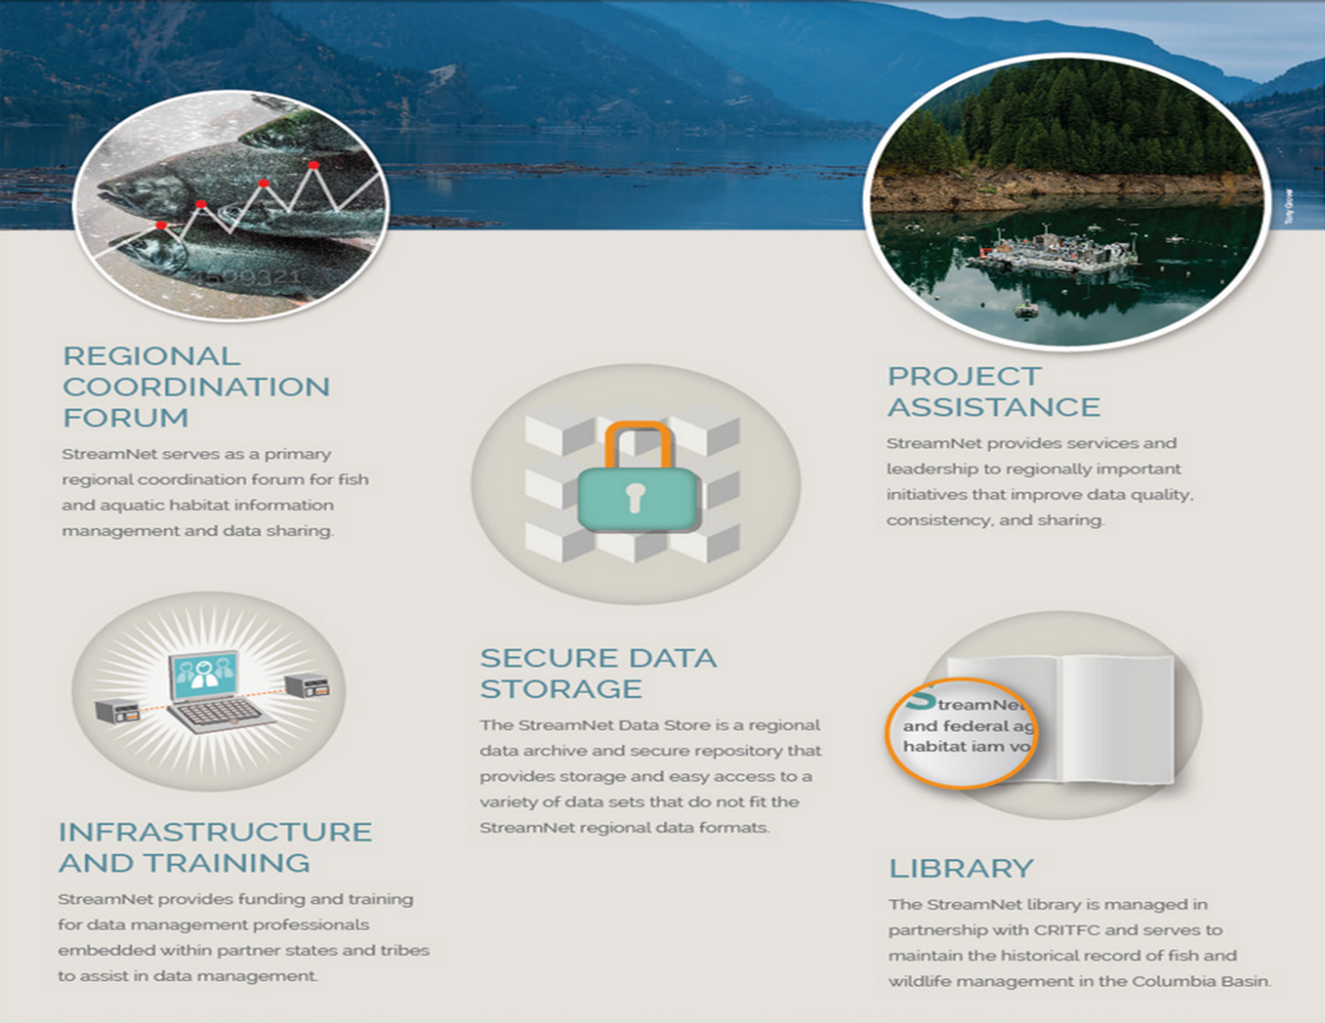
Photos courtesy of Tony Grover

Staff at PSMFC and subcontracting agencies also provided leadership in other projects in 2014, including implementation of a BPA initiative to ensure that data collected with BPA funding were protected in secure data repositories. StreamNet made revisions to the Data Store to make it more accessible as a “Repository of Last Resort” for any BPA projects without specified repositories that were identified in the 2013 Database Backup Assessment and Inventory. Staff also provided leadership and support for a successful workshop on hand held technology for fish data projects in collaboration with PNAMP and Sitka Technologies. This was a direct outgrowth of the Device Trials project which was instituted to test automated data flow and hardware capability in field projects. StreamNet staff also led a database integration workshop involving the BPA-sponsored data management projects located at PSMFC. Improvements were made to multiple systems as a direct result.

The StreamNet subprojects in the state agencies all contributed to development or improvement of agency data storage systems in 2014. Additional resources were allocated to partners at ODFW, IDFG, and WDFW through cost savings made at PSMFC. This was made possible in part through PSMFC assumption of additional BPA contracts in 2014, including the Habitat Evaluation Procedures project (HEP) and the Fish Data Products Project. StreamNet is also a subcontractor to WDFW for the EPA Coordinated Assessments grant.

A wide variety of data was disseminated through the StreamNet website in 2014 (www.streamnet.org). Overall visits to the site decreased somewhat in the past year, possibly because data updates have slowed and CA data has not yet been made publicly available;

2014 was the first year of the project’s Executive Committee. Management and policy level specialists at tribes, states, and federal agencies were recruited to serve on this group. Their primary function is to provide guidance and leadership to the StreamNet project to ensure that data management resources and work efforts are aligned with agency and regional priorities. The initial accomplishments of the group included drafting of a Strategic Plan for StreamNet and establishing FY 2015 priorities for the CA project.

